|  |
| --- |
|  |
| Final Project Report  Jackson Farley, Erik Leinen, Ellie Langley |
| |  |  |  | | --- | --- | --- | | Spring 2019 | 5/10/19 | ELC 4438 | |

# Project Summary

This device is implemented on a smart walker and determines whether the walker is being used and at what time. When not in use, the device gently reminders the user to use the walker, and when the gentle reminder fails, the harsh reminder is enacted. As more and more elderly use walking aids, and as the elderly population is more susceptible to injurious falls, it is difficult for an elderly person to achieve independence safely. This device will allow the elderly who require walking aids to live by themselves safely.

This device utilizes sensors to detect human presence on the upper and lower part of the walker. Depending on whether a human presence has been detected from the lower sensor, the upper sensor will then take a measurement. If the upper sensor has also taken a measurement with a proximal signal, then the device will output a “gentle reminder” by lighting the LED modules on the walker a solid yellow. If the walker has still not been used, then the device will output a “strong” reminder by flashing the LEDs red. When the buttons on the walker are pressed, the walker will go to an “in use state”. A time stamp will be taken using a clock module and output to the SD card module.

Most of the electrical parts for the smart walker have been placed within a plastic, red Sparkfun box, with holes drilled for wires which need to go outside the box. The two push buttons have been placed on the handlebars of the walker. The device is powered by 9V batteries.

# Project Objectives

1. Measure Human Presence: Use two sensors to detect the presence of the user effectively.
2. Time Accuracy: Maintain correct date and time for data logging.
3. Reminders: Send a reminder to the user if the walker has not been used but can sense the user’s presence.
4. Lightweight: The device will be lightweight as to not disrupt the balance of the smartwalker and will take up minimal space.

# Selected Hardware Platform

The Arduino Mega 2560 was selected as the hardware platform, as the sensors purchased for the project best interface with the Arduino IDE. The Arduino mega also has many digital pins that can be used as GPIOs, meaning that for the components which utilize GPIO pins there is plenty of space.

The Arduino Mega also has pins that can be configured as interrupts. This is important because the buttons implemented in this project must be configured as interrupts for the purpose of the device to be achieved.

Additionally, the Arduino Mega has SCL and SDA lines to allow for ease of I2C usage, as many components for this project use I2C capabilities.

# Hardware Design Description

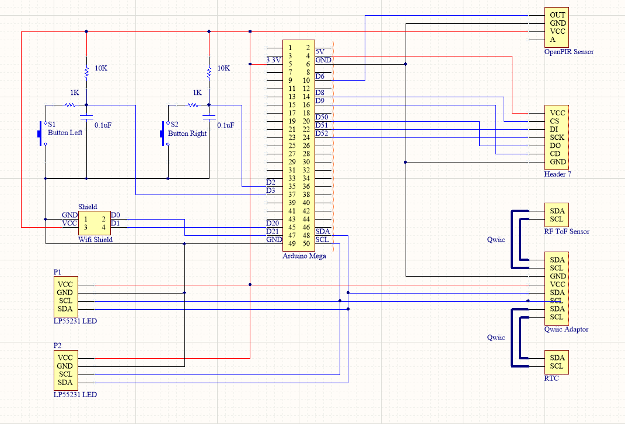

Figure : Final Schematic for Smartwalker

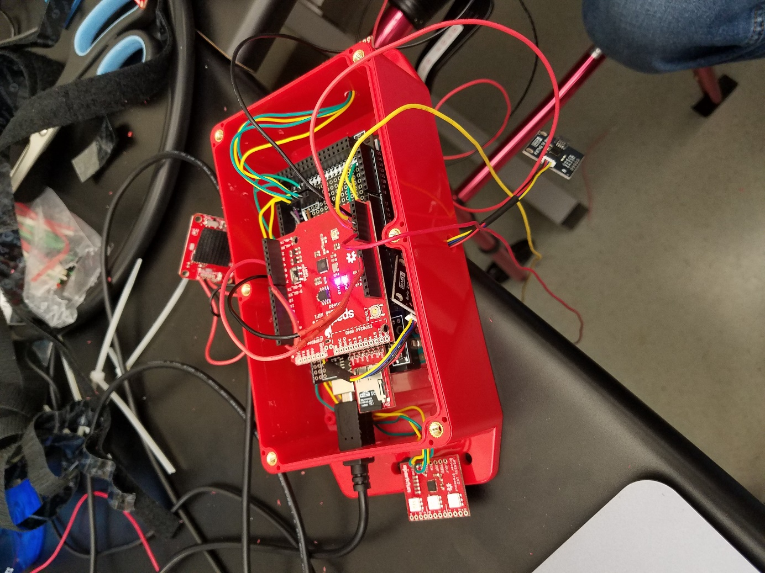

Figure : Hardware Implementation

1. **Arduino Mega 2650**

* Multiple digital pins, etc.

1. **Sensor 1**—Sparkfun Distance Sensor Breakout – RFD77402 (Qwiic)

* Detects human presence up to 2 meters with I2C

1. **Sensor 2**—Sparkfun OpenPIR Sensor

* Measures for human presence and returns a 1 or 0 depending on whether human presence is detected

1. **LEDs**—Sparkfun LP55231 LED Driver Breakout

* Interfaces with I2C and three RGB LEDs for different colors and flashing

1. **GPIO Buttons**—Momentary push button

* Simple GPIO buttons, values can be read by Arduino mega
* Debouncing methods required

1. **SD Card Module**—Sparkfun Level Shifting microSD Breakout

* Allows for mass storage of data on the Arduino Mega

1. **Clock**—Real Time Clock (Qwiic) – RV-1805

* Maintains accurate date and time for logging

1. **Adapter for I2C Sensors**—Sparkfun Qwiic Adapter
   * For easy use of multiple I2C Qwiic sensors on the Arduino mega

**Chosen software platform**

**Software Design**

***Overall***